|  |  |  |  |  | logo1.png |
| --- | --- | --- | --- | --- | --- |

| Course Name | | Zoho Books | |
| --- | --- | --- | --- |
| College Name | | Mangayarkarasi College of Arts and Science for Women Paravai, Madurai - 625002 | |
| College Code | | MKU251 | |
| Skill Offering Id | |  | |
| Project Title | | Preparation and Maintanence of ZOHO Books for Dream Homes Realty | |
| Project Submitted To | | Madurai Kamaraj University ( Naan Mudhalvan Scheme(TNSDC)) | |
| Year | | 2023 | |
| Department | | B.COM Computer Application | |
| Semester | | 5 | |
| Group Number | | 5 | |
| Total Members of the Group | | 4 | |
| Group Members Details | | | |
| Name of the Member | University Register. No | | Student NM ID |
| NISHANTHI R | C1C15168 | | CB72FAE5D11CA58BDD548E0ED54AEF1A |
| SRINITHI M | C1C15185 | | CFE11C9DC910ADCBFA845D9AF736065C |
| KOWSALYA M | C1C15162 | | 24977C5DC7BE4FD814840EECBAB76B2C |
| VIJAYA LAKSHMI S | C1C15194 | | A2EA88690837DFE90A244857FFA6E3BD |
|  |  | |  |
| Under the Guidance | | Mrs. N. Punitha Martina Nesamani | |
| SPOC | | Ms.P.UMADEVI | |

**Dream home realty**

1. **Introduction.**

*1.1 Overview*

Dream Homes Realty, a construction company, uses Zoho Books to track project expenses, manage

subcontractor payments, and handle invoicing. They can generate estimates and invoices for clients,

track job costing, and monitor the profitability of each project. Zoho Books provides them with financial

insights to make informed decisions.

*1.2 Purpose*

We are a leading construction company committed to delivering exceptional building solutions.

1. **Problem Definition and Design Thinking**
   1. Empathy Map

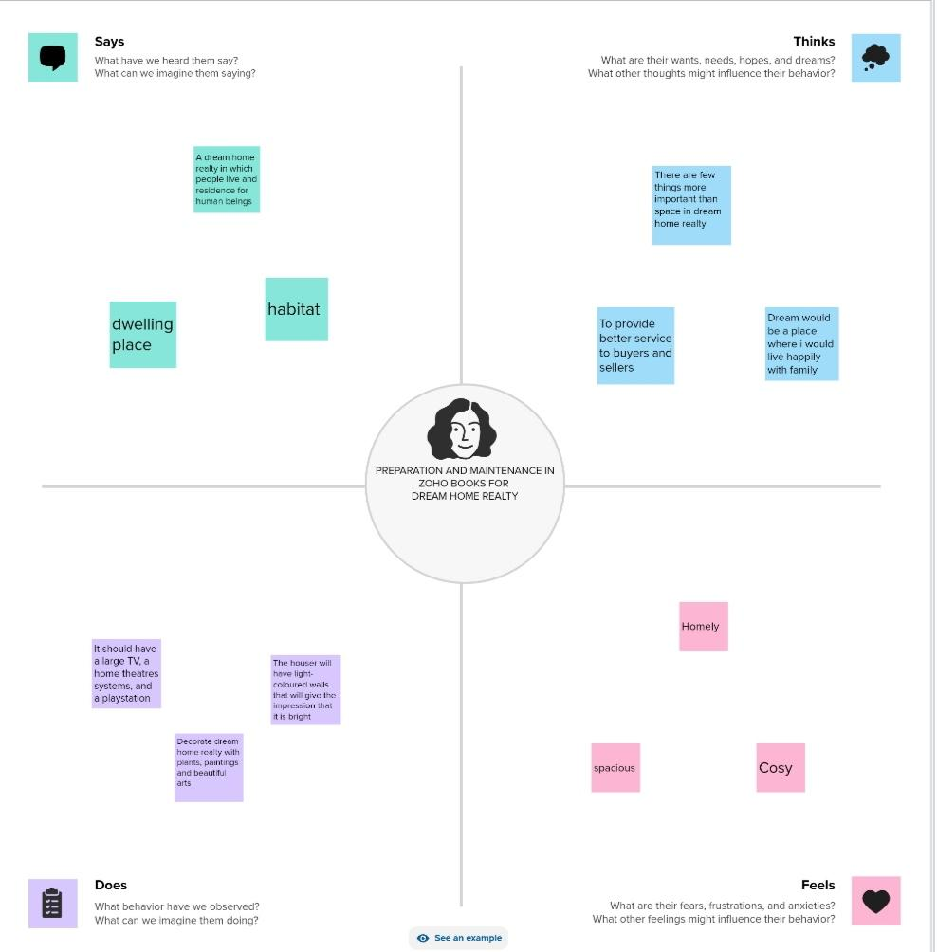

2.2 Ideation and Brainstroming Map

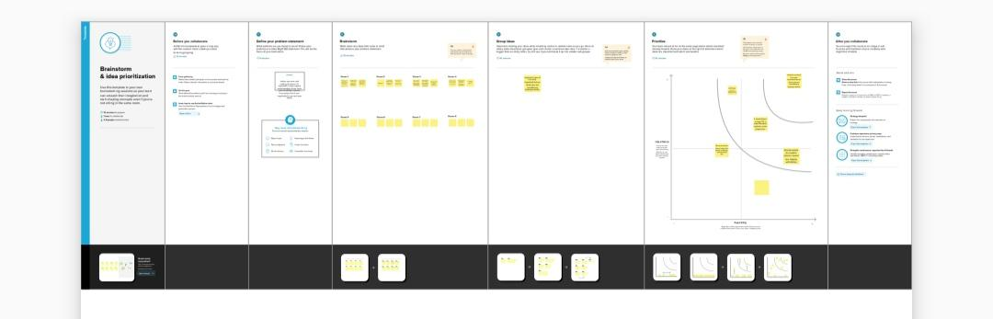

1. **Milestone 1: Set up your account**

Activity 1: Sign up for a Zoho Books account and Login

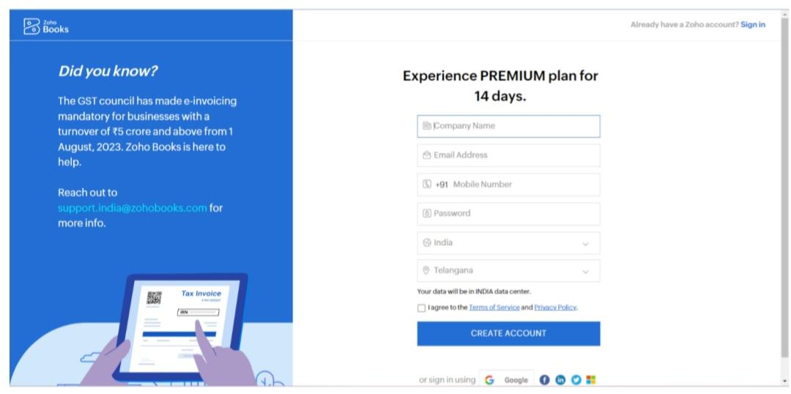

Activity 2: Introduction

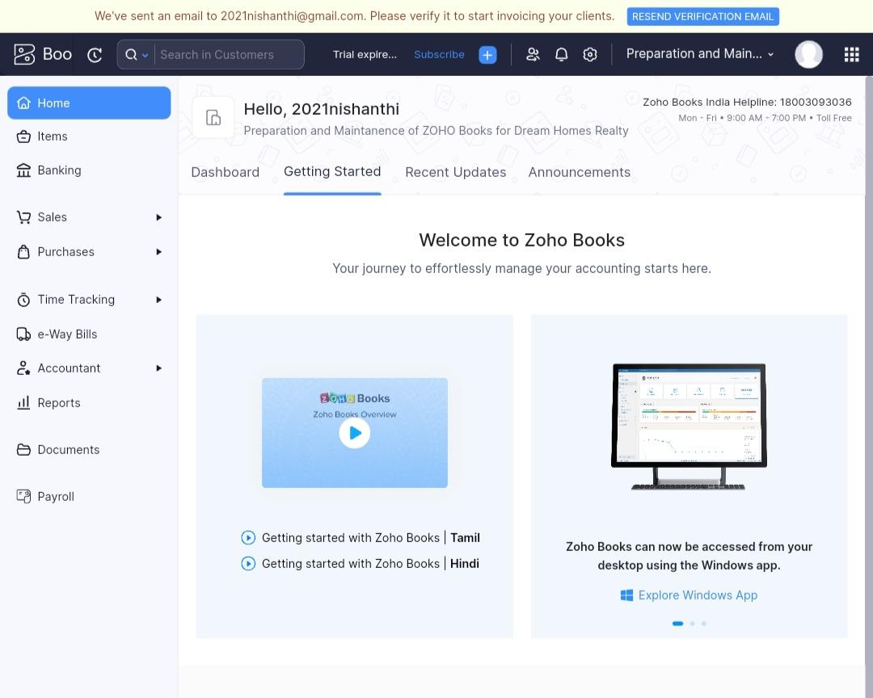

1. **Milestone 2: Service Creation:**

Activity 1: Creation

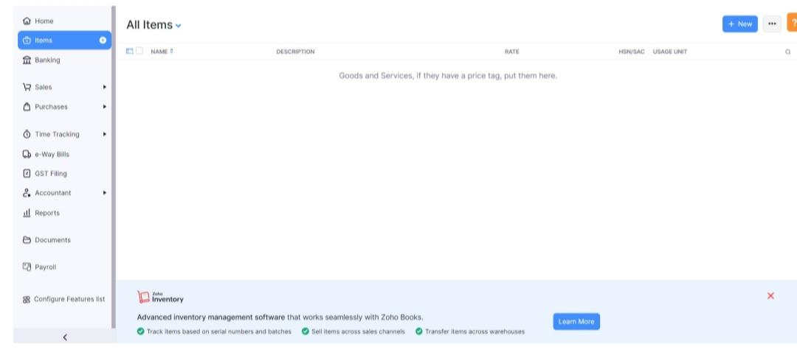

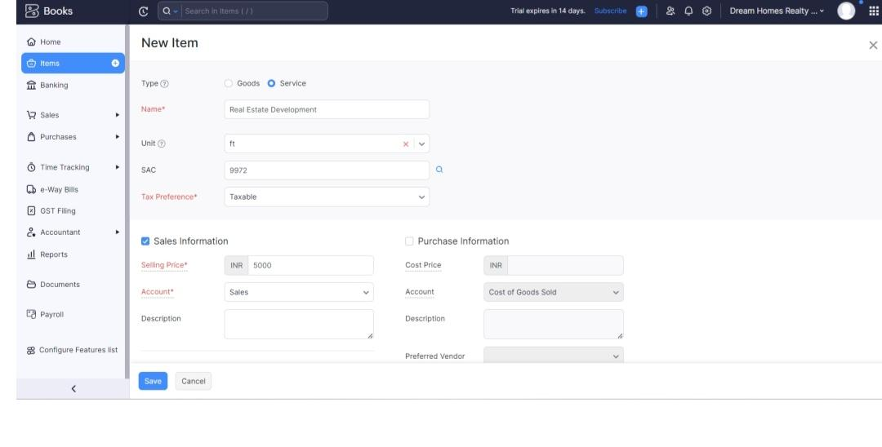

Activity 2: Review of Items after Addition

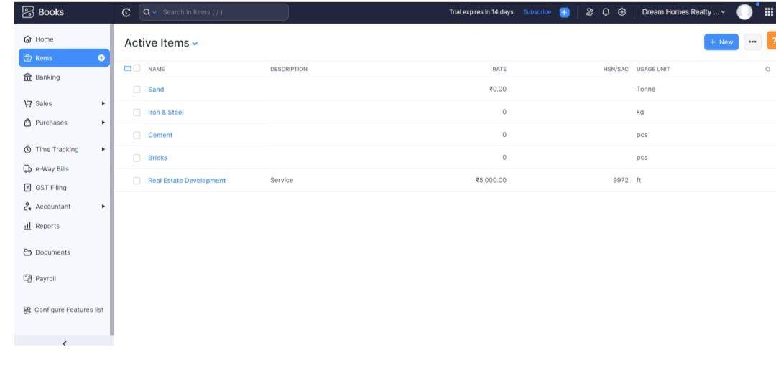

**Milestone 3: Vendors**

Activity 1: Vendors Creation

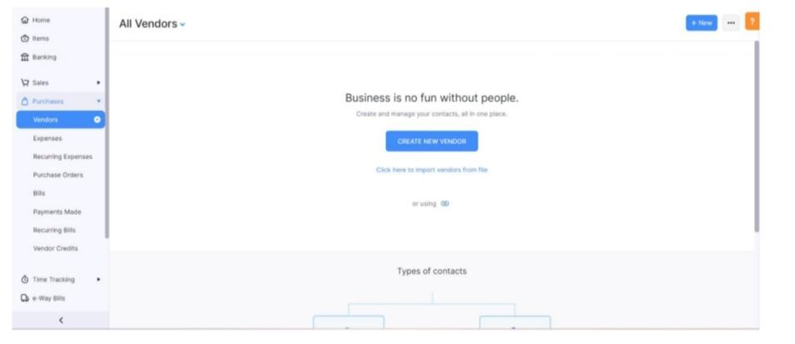

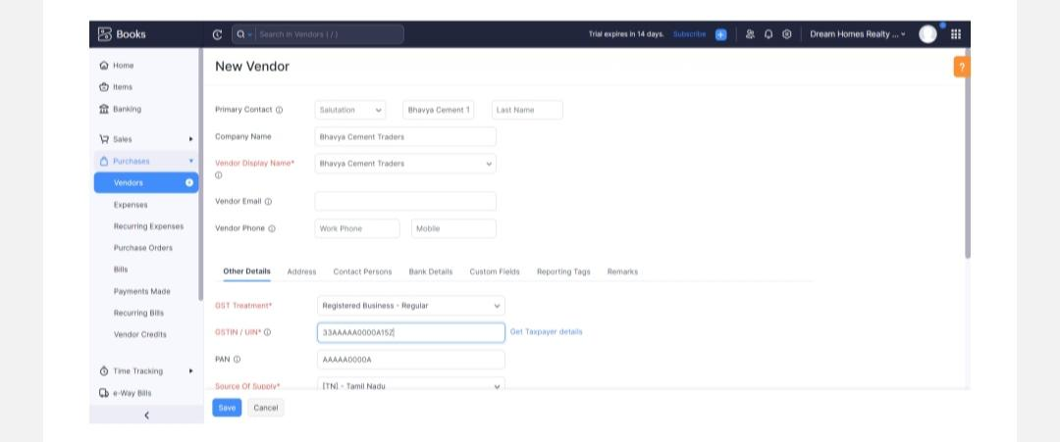

**Milestone 4: Purchases**

Activity 1: Purchase Order Creation

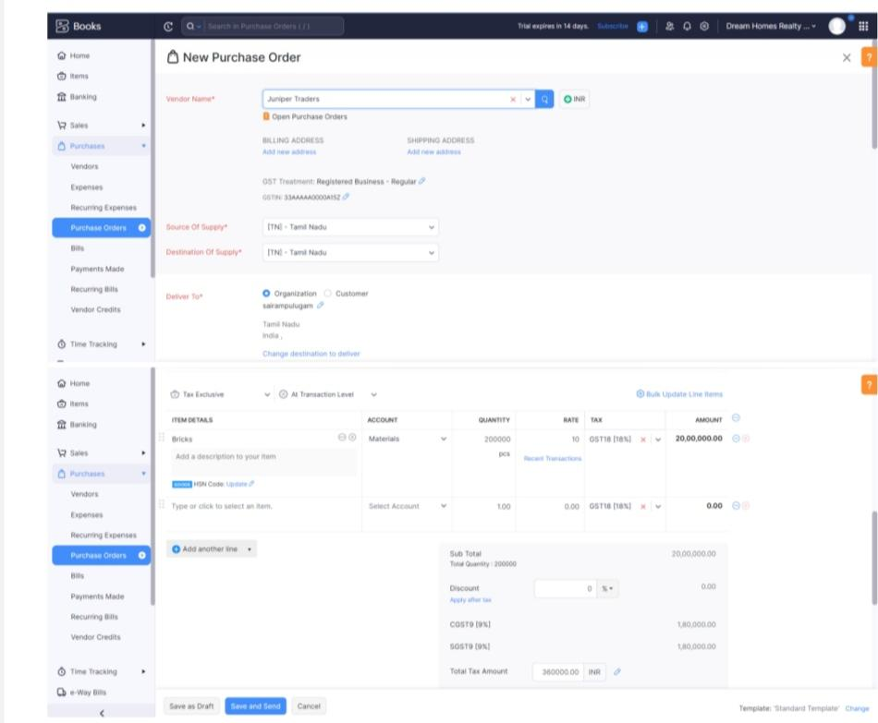

Activity 2: Purchase Order to Purchase Bills Convertion

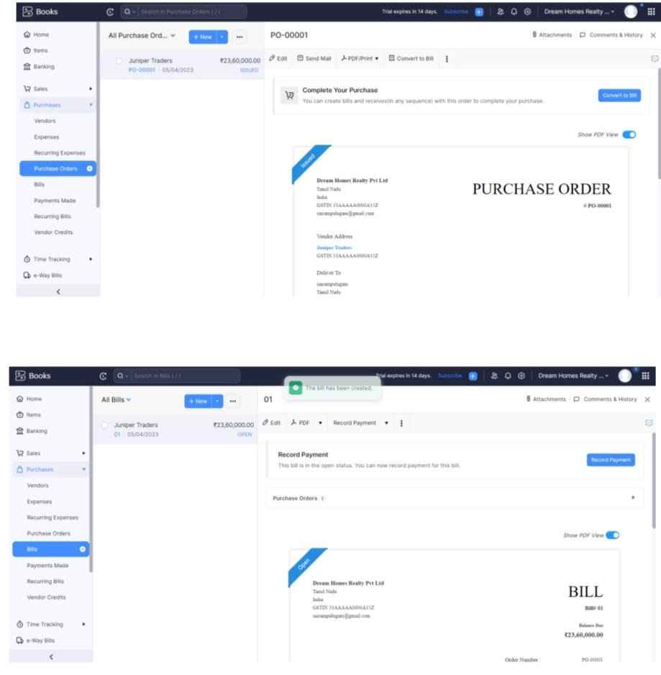

Activity 3: Direct Vendor Purchases Bills Creation:

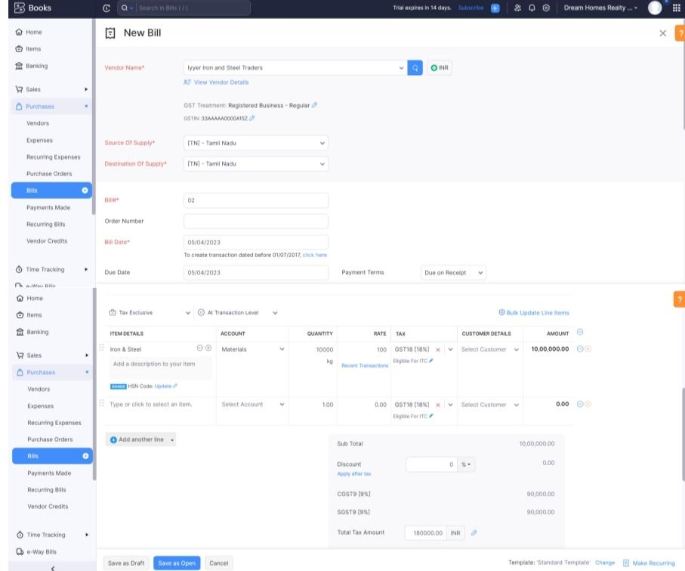

Activity 4: Reconciliation of Open & Outstanding Bills



**Milestone 5: Customers**

Activity 1: Customers Creation:

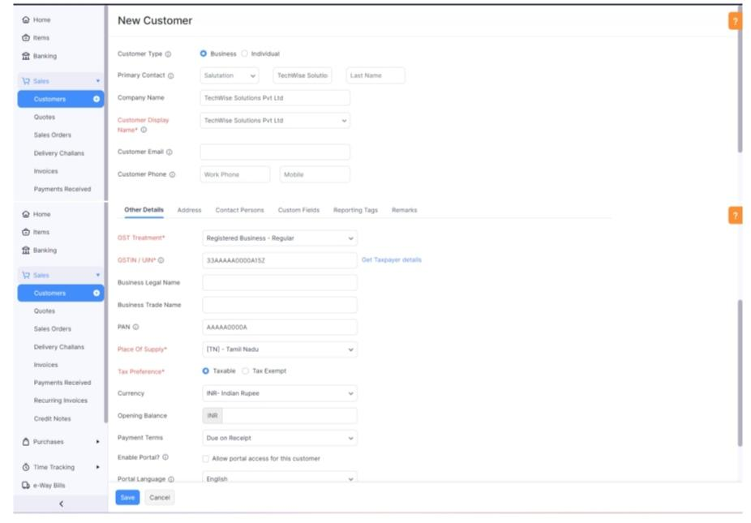

Activity 2: Review the Customers List

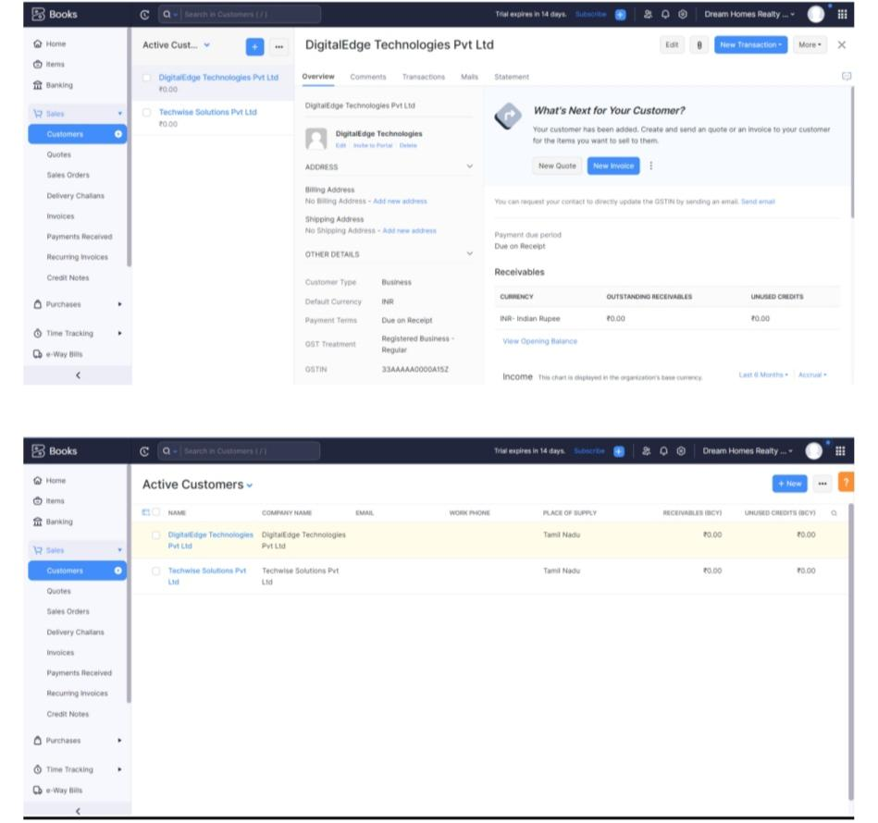

**Milestone 6: Sales**

Activity 1: Sales Order Creation

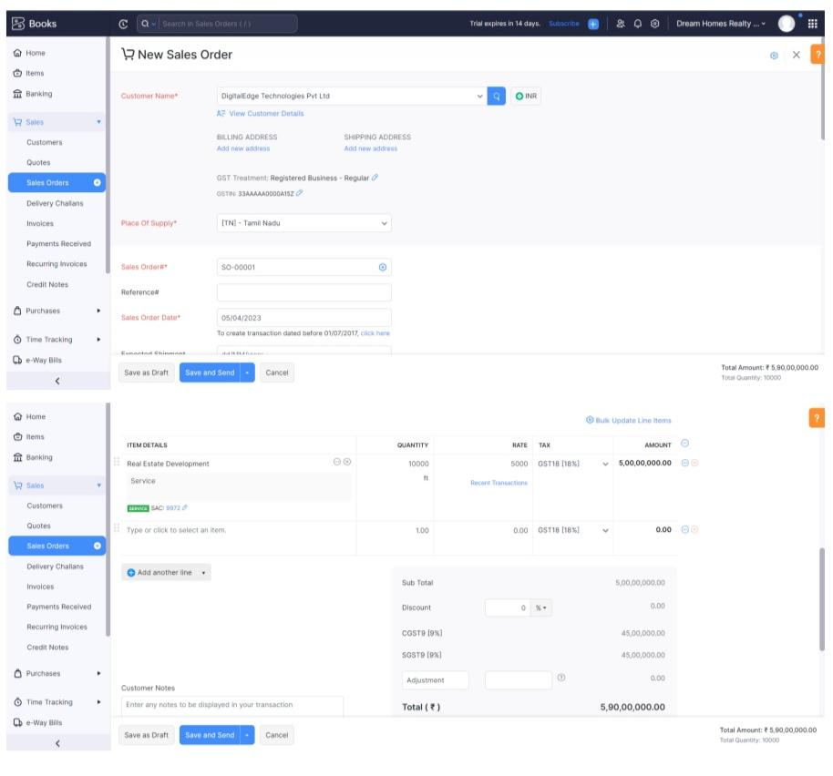

Activity 2: Sales Order to Sale Invoice Convertion

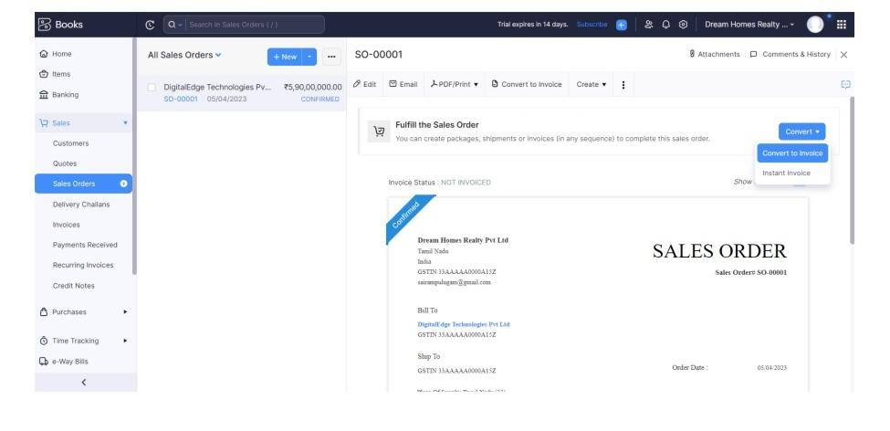

Activity 3: Direct Sale Invoices

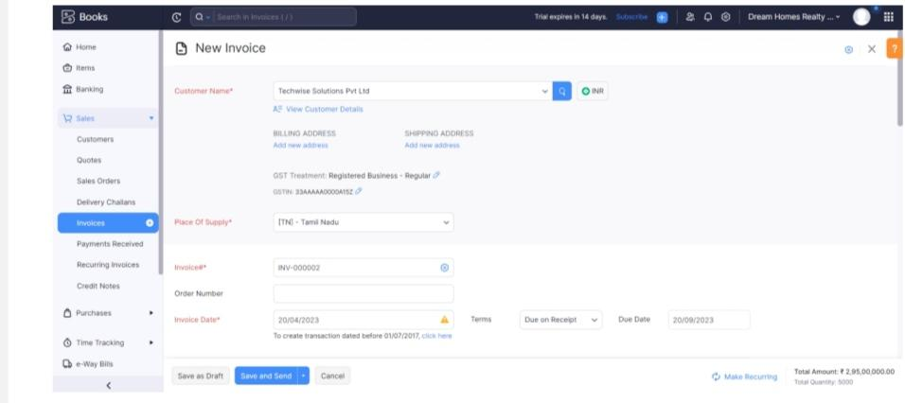

Activity 4: Reconciliation of Open Invoices

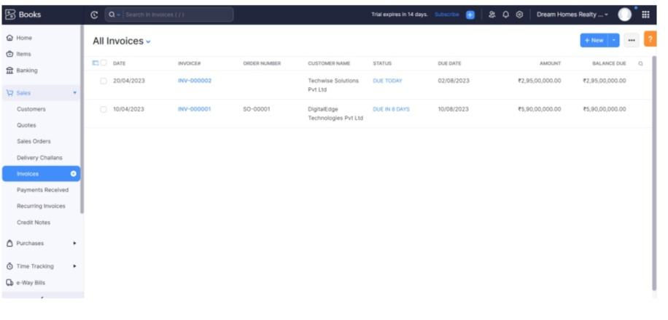

Activity 1: Profit and Loss Account

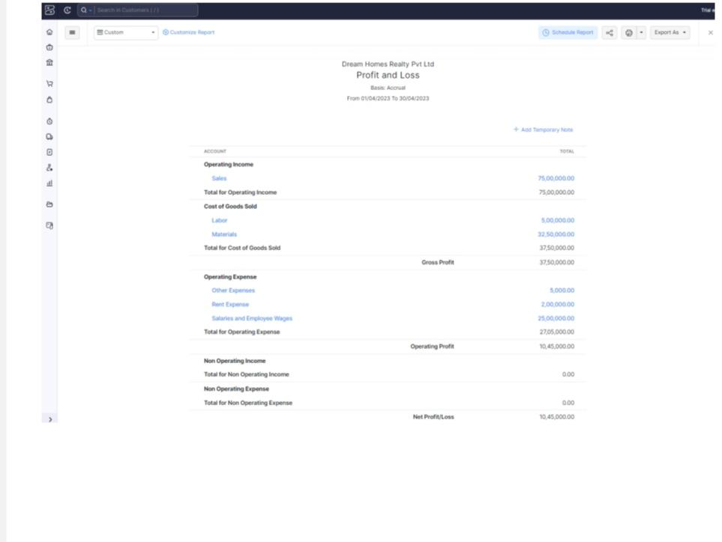

Activity 2: Balance Sheet

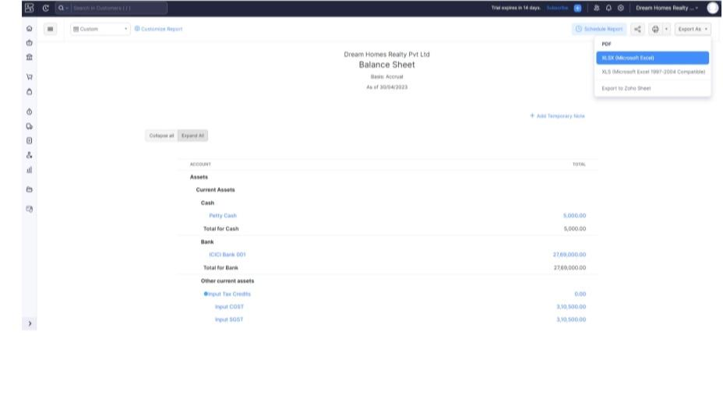

Activity 3: GST Reports

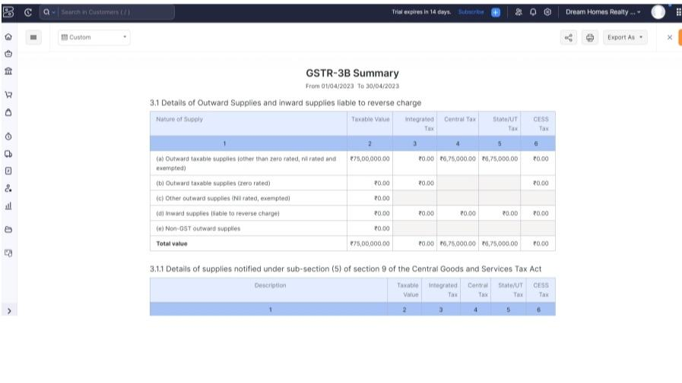

Activity 4: Journal Report

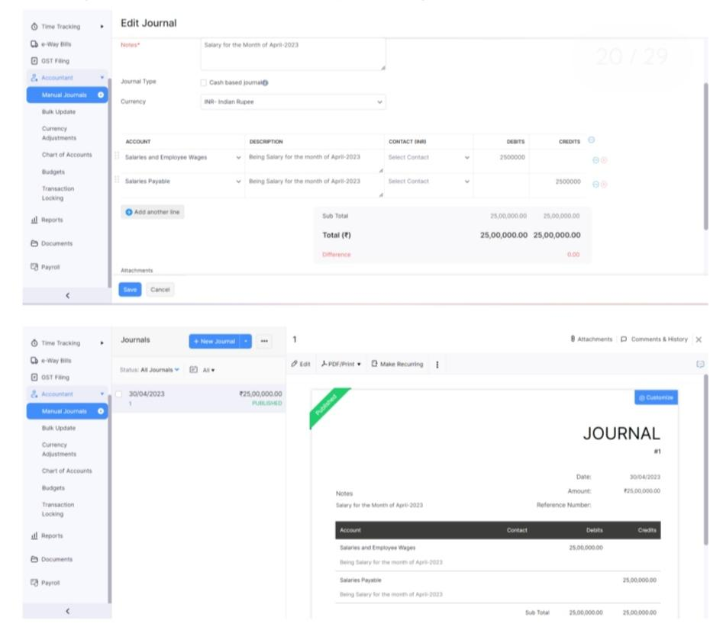

***4. Advantages :***

* Rent payments may be lower:

This certainly can be true if you’re renting an apartment, and it also may be the case when renting an identical house. If a mortgage is more than you can afford, renting makes more sense than being stretched too thin financially.

* Repairs aren’t your responsibility:

The property owner has to pay for that leaky faucet and anything else that breaks or wears out. So, you don’t have to factor those unplanned expenses into your budget.

* Flexibility:

Your obligation to a place you rent can’t exceed the length of the lease, and if the property owner can quickly find a new tenant, that can get you off the hook if you leave before the lease expires.

***Disadvantages:***

* You aren’t building value:

When you leave your rental, all you take with you is yourself and the furniture and dishes that belong to you. It’s the property owner’s equity that grows, not yours.

* Rent may increase:

You may be comfortable with what you’re paying each month, but that could change when your lease comes up for renewal, typically in six months or a year.

* No credit score improvement:

While paying a mortgage on time improves your creditworthiness, you don’t get the same benefit from rent.

* No cosmetic improvements:

If the home you are renting looks dated, you may just have to get used to it.

1. **Conclusion:**

For many people, owning a home is a cornerstone to a life-long financial puzzle. It’s a major life purchase because of the large amount of money needed for the investment.

1. **Future scope:**

The real estate sector is going to continue on its journey of long term growth as we see a continuous rise in GDP per capita, larger disposable incomes, growing urbanization and most of all a larger focus of the world on us as the next big economy."